Bowling Green Jr. Bobcat Football

Liability Clause
I/we the Parents/legal Guardian of the above named Participant in the Jr. Bobcat Youth Football Association hereby give my/our approval to their participation in any and all activities during the season. I/We assume all risks and hazards incidental to such participation, including transportation to and from all activities. I/We hereby waive, release, absolve, indemnify and agree to hold harmless the Jr. Bobcat Youth Football Program, its organizers, sponsors, supervisors, board members, other participants, and any persons transporting the Participant, except the extent and in the amount covered by accidental or liability insurance.

Consent
I/We by signing below authorize Jr. Bobcat Football to input the above named Participants information and pictures into the Jr. Bobcat Youth Football website and program. I/We understand that this information may have to be sent electronically and I/We will not hold Jr. Bobcat Football responsible for the security of such transmission.

Concussion Information
I/We by signing below verify that we have reviewed the information on the website www.healthyohioprogram.org/concussion regarding concussions and return to play for youth sports organizations.

Parent/Legal Guardian Sign: _________________________Print:________________________

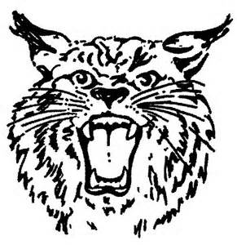
Date:______________ Verified By:________________________________________________

