IMPORTANT INFORMATION
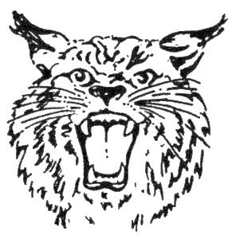
IN ORDER HELP US COMMUNICATE MORE EFFECTIVELY, WE WILL USE TWITTER TO SEND OUT ALERTS AND REMINDERS.
TO ACCOMPLISH THIS WE NEED EACH FAMILY TO FOLLOW US ON TWITTER. THERE IS NO COST. THE INSTRUCTIONS FOR THIS ARE BELOW. PLEASE DO THIS AS SOON AS POSSIBLE.
TO FOLLOW US ON TWITTER ON YOUR CELL PHONE (NO TWITTER ACCOUNT IS NEEDED)
TEXT - follow bgjrbobcats to 40404
IF YOU ALREAD HAVE A TWITTER ACCOUNT
SEARCH FOR bgjrbobcats and CLICK THE FOLLOW BUTTON
YOU CAN ALSO FOLLOW THE LINK THROUGH THE WEBPAGE

ALL PARENTS MUST GO TO THE WEBSITE www.healthyohioprogram.org/concussion and review the information regarding concussions and return to play for youth sports organizations.

FITTINGS WILL BE JUNE 22ND - 5 – 8PM AT BOWLING GREEN HIGH SCHOOL. A SKILLS ASSESSMENT WILL TAKE PLACE ON MONDAY JUNE 22ND AT OUR FITTING.
MANDATORY CONDITIONING/PRACTICE BEGINS AUG 3 AT 6PM – 8PM AT BG HIGH SCHOOL PRACTICE FIELDS.
A PARENT MEETING WILL TAKE PLACE AT THE END OF THE FIRST PRACTICE.
ALL REMAINING PAPERWORK IS DUE ON THIS DAY.
CALENDARS AND SCHEDULES WILL BE DISTRIBUTED AT THIS TIME.

