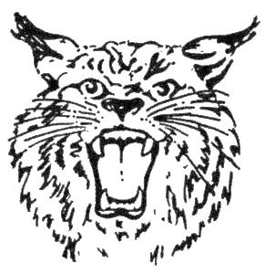
ATHLETE’S RELEASE

I understand that my participation in all BGJBF activities presents and dangers of a serious and permanent bodily injury or death. I, or my parent/guardian if I am a minor, hereby release, hold harmless, discharge, and agree not to sue the BGJBF its Directors, Officers, Volunteers, Coaches, Officials, Owners, or Leasers of Premises for all liability from my participation in any BGJBF related travel, lodging, or social/recreational activities. Those under 18 must have parental permission.

Athlete Signature ___________________________________

Parent/Guardian Signature ________________________ Date ________

PLAYER CODE OF CONDUCT

- I will respect coaches and officials at all times.

- I will respect my teammates and members of the opposing team at all times.

- I will come to practice prepared to play, give 100% effort, and to have fun.

- I understand that the coach has the final decision on what position I play.

- I will act in a positive manner towards my team, coaches, fans, and members of the opposing team whether my team wins or loses.

- I understand that paying attention during games and practice is extremely important to avoid injury and improve my football skills.

- I will NOT use foul language or be abusive to anyone.

- I understand that I represent Bowling Green Jr. Bobcat Football even off the playing field and I will behave at all times in ways that proudly support the program.

I understand that failure to follow these guidelines could lead to loss of playing time, suspension of games, and/or dismissal from the league.

Player Signature _________________________________

Parent/Guardian Signature ________________________________________ Date _____________

